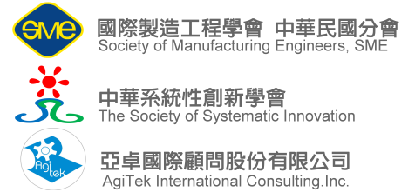

Course Description Sheet
Course Title:  SYSTEMATIC BUSINESS MODEL INNOVATION  系統化商業模式創新 |  | Instructor(s):  Valeri Souchkov
Course Descriptions：(Background/Purpose/Special Features of the course. The goal of this section is to interest target participants.)
課程概要
At this course the participants will learn how to innovate their business models through identifying bottlenecks in the existing business models which can not be easily solved with known methods and generating innovative ways of overcoming these bottlenecks to achieve maximum benefits.
這堂課學員可以學習到如何透過識別不意被發現的瓶頸，藉由系統性的工具，創新商業模式，以達到最大效益
The course content is based on integration of Business Model Canvas approach and TRIZ, a Theory of Solving Inventive Problems.
此課程透過目前全世界最完整的創新手法萃智(TRIZ)，創造嶄新的商業模式與解決問題技術
Course Benefits：(What can be achieved after the class.) 課程效益
- Understanding TRIZ: a systematic approach to deal with innovative challenges.
了解TRIZ如何透過系統性達到創新的挑戰
- Learning Business Model Canvas how to model a business.
學習透過商業模式藍圖將商業模式化
- Learn how to identify critical business model bottlenecks.
學習識別商業模式中的關鍵瓶頸
- Learn patterns of innovative business model solutions.
學習創新解決商業模式之常態
- Ability to use the techniques learned by the participants independently in their everyday activities.
希望能讓學員學習到技術與技能，達到能獨立運作於他們的工作職場中
- Cases and Practice.
演練習題
- Certificate of accomplishment by the TRIZ Training International Centre.
學習結訓證明
Pre-requisite (if any):
No
Hours: 8 | Time slot：□ ■  ■ any □ Weekend □ Weekday □ Other: ______
Targeted participants:
Everyone who is interested in business innovation: business professionals, business managers, team leaders, management consultants, change managers, productivity and quality professionals, executives, students of business and management disciplines, problem solvers.
此課程適合企業主管、企業發展者、策略者、企業問題解決者

One sentence theme (slogan): (Used as subject in the e-mail title to call readers’ attention.)
Innovate your business model with a systematic approach
讓系統化思維提升商業創新模式
Course Outline：(also approximate schedule plan.)
- 商業模式介紹 Introduction to Business Modeling
- 發掘潛在挑戰與機會 Extraction of potential challenges and opportunities
- 藉由理想性與資源創新輔佐現有商業模式
Using Ideality and Resources to innovate existing business models
- 識別價值衝突鏈建構關鍵因素
Value-Conflict Mapping (VCM) to identify and structure critical contradictions.
- 進行關鍵因素排序與選擇
Ranking and selection of critical contradictions in a business model.
- 討論解決商業模式衝突案例分享
Discovering and solving contradictions in business models and practice
Most related literature/book/software (if any):

References: (optional)

