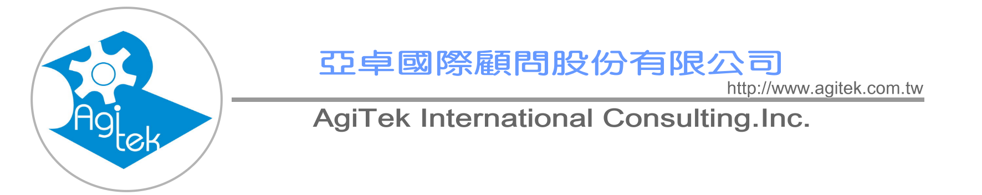

Motorola Lean Six Sigma® Green Belt Training and Certification Program

Program Participants
Managers, Project Leaders, Senior Engineers, Green Belt Candidates
and anyone who desires an understanding of Lean Six Sigma principles
and skills. No previous Six Sigma and Lean experience is required.

Program Overview
Motorola University’s Lean Six Sigma training combines lectures with simulation exercises to give
participants the opportunity to follow a structured improvement methodology. Using the DMAIC model,
it teaches participants how to apply Lean principles and tools in conjunction with the Six Sigma rigor
and methodology to achieve rapid and significant improvements with greater speed and reduced
process variation.

Upon Completion, the Participant Will Be Able To:
. Simultaneously improve both quality and speed by combining Lean with Six Sigma
. Understand the Lean Six Sigma methodology and improvement processes
. Properly define, scope and work on Lean Six Sigma projects
. Construct a Value Stream Map and apply the map to identify improvement opportunity
. Learn to recognize waste
. Incorporate a comprehensive set of quality tools to problem solving
. Implement quick improvements using a structured Kaizen Event
. Learn to mistake-proof a process to reduce rework
. Apply SPC and visual process management to monitor the process
. Use MINITAB® 14 to enhance analysis for process improvement projects
Program Length
6 days
Certification
We offer the option of formal Green Belt certification. It requires that your Green Belt candidates
complete training, pass a test, lead and successfully complete one Green Belt project. Project
will be assessed for business impact (financial and/or “soft-dollar” impact) as well as Lean Six
Sigma skill demonstration.
Software
Participants need to bring a laptop computer preloaded with Microsoft Excel ( Windows 97 or
higher ) and MINITAB®. They will receive Excel add-ins for additional statistical functionality.
Location
This program is available either as open enrollment training at a Motorola site or as onsite
training at a location of your choice.

Motorola Lean Six Sigma® Green Belt Training and
Certification Program Content

Define Opportunity - What is important?  Select business improvement opportunity  Develop project team charter  Define customer requirements  Document business processes  Understanding basic concepts | Measure Performance - How are we doing?  Achieve an in-depth understanding of the process using value  stream mapping  Determine what to measure  Develop effective data collection methods  Evaluate measurement systems  Determine process performance
Analyze Opportunity - What is wrong?  Identify potential root causes  Implement comparative methods  Conduct Sources of Variation (SOV) study  Conduct correlation and regression analysis | Improve Performance - What needs to be done?  Develop potential solutions  Evaluate and select solutions  Develop “To Be” Value Stream Map  Develop and implement pilot run
Control Performance - How do we guarantee performance?
Mistake-proof the process to eliminate defects from the process
Complete all documentation including SOPs, Process Control
Plans, and Training Plans
Develop a monitoring system and implement SPC and Visual
Process Controls to provide feedback on the process


http://www.agitek.com.tw/
6F, Tsing-Hua Info. Building, No.352, Kuang-Fu Rd., Sec. 2, Hsinchu,
Taiwan 30071, R.O.C.
TEL：886-3-572-3200 FAX：886-3-572-3210

A Global Network of Innovation and Intelligence

