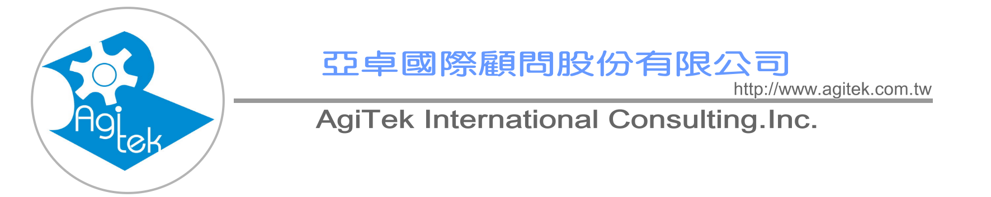

Motorola Lean Six Sigma® Black Belt Training and Certification Program

Program Participants
Managers, Project Leaders, Senior Engineers, Black Belt Candidates and anyone who desires an understanding
of Lean Six Sigma principles and skills. No previous Six Sigma and Lean experience is required.

Program Overview
Motorola University’s Lean Six Sigma training combines lectures with simulation exercises to give
participants the opportunity to follow a structured improvement methodology. Using the DMAIC model,
it teaches participants how to apply Lean principles and tools in conjunction with the Six Sigma rigor
and methodology to achieve rapid and significant improvements with greater speed and reduced process
variation. Participants will also learn how to play their role and effectively manage, support and motivate
their teams and how to apply project management skills to achieve the desired goals.
Motorola University’s approach to developing Lean Six Sigma experts is based on an Action Learning
Model. This model combines classroom instruction with real-time project implementation and application
coaching. Your journey to becoming a Lean Six Sigma expert will span four months, alternating between
spending one week in training, and three weeks back on the job applying the tools and techniques you
learned to complete your project.

Upon Completion, the Participant Will Be Able To:
. Simultaneously improve both quality and speed by combining Lean with Six Sigma
. Understand the Lean Six Sigma methodology and improvement processes
. Properly define, scope and work on Lean Six Sigma projects
. Gather Voice of the Customer and analyze survey data
. Construct a Value Stream Map and apply the map to identify improvement opportunity
. Learn to recognize waste
. Apply Lean tools to analyze process flow and delay times and focus on the separation of “value-added”
from “non-value-added” and work with tools to eliminate the root causes of non-value-added activities
. Incorporate a comprehensive set of statistical analysis tools to problem solving
. Provide a means for quantifying and eliminating the cost of complexity
. Investigate basic queuing problems
. Implement quick improvements using a structured Kaizen Event
. Learn to mistake-proof a process to reduce rework
. Apply SPC and visual process management to monitor the process
. Use MINITAB 14 to enhance analysis for process improvement projects
Program Length:
20 days (5 days/week, 1 week/month)
Program Participants
Managers, Project Leaders, Senior Engineers, Black Belt Candidates and anyone who desires an understanding
of Lean Six Sigma principles and skills. No previous Six Sigma and Lean experience is required.
Certification
We offer the option of formal Black Belt certification. It requires that your Black Belt candidates complete training, pass a test, lead and successfully complete one Black Belt project. Project will be assessed for business impact (financial and/or “soft-dollar” impact) as well as Lean Six
Sigma skill demonstration.
Software
Participants need to bring a laptop computer preloaded with Microsoft Excel ( Windows 98 or higher ) and MINITAB®. They will receive Excel add-ins for additional statistical functionality.

Motorola Lean Six Sigma® Black Belt Training and Certification
Program Content

Define Opportunity - What is important?  Identify and validate business improvement  opportunity  Document and analyze business processes  Define customer requirements  Build and launch effective project teams | Measure Performance - How are we doing?  Achieve an in-depth understanding of the process  using value stream mapping  Determine what to measure  Develop effective data collection methods  Understand and measure variation  Evaluate measurement systems  Determine process performance
Analyze Opportunity - What is wrong?  Identify process constraints and bottlenecks  Narrow down to the Potential Root Causes Confirm Root Cause to Output Relationship Estimate Impact of Root Causes on Key Outputs and assess the impact of process complexity Prioritize Root Causes | Improve Performance - What needs to be done?  Develop potential solutions  Evaluate and select solutions  Develop “To Be” Value Stream Map  Develop and implement pilot run  Confirm attainment of project goals  Develop full scale implementation plan
Control Performance - How do we guarantee performance?
Mistake-proof the process to elimnate defects from the process
Complete all documentation including SOPs, Process Control Plans, and Training Plans
Develop a monitoring system and implement SPC and Visual Process Controls to provide feedback
on the process


http://www.agitek.com.tw/
6F, Tsing-Hua Info. Building, No.352, Kuang-Fu Rd., Sec. 2, Hsinchu,
Taiwan 30071, R.O.C.
TEL：886-3-572-3200 FAX：886-3-572-3210

A Global Network of Innovation and Intelligence

A Global Network of Innovation and Intelligence

