TRIZ Master- Valeri V. Souchkov 简介 (苏联裔荷兰籍)
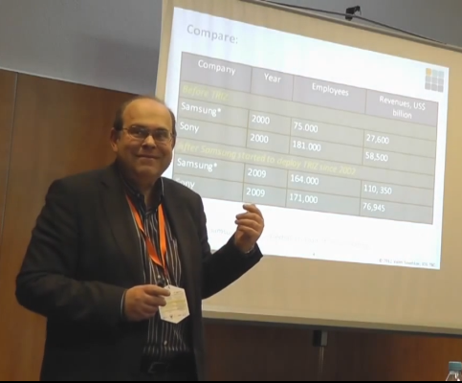
【现职】
- ICG Training & Consulting国际TRIZ训练中心创办人，并任训练中心主席
ICG Training & Consulting, Enschede, The Netherlands.
Founder, Managing Director, Trainer, Consultant, Developer
- Development of TRIZ and xTRIZ tools and xTRIZ framework establishing a Process of Systematic Innovation with TRIZ.
- Training and consulting customers on TRIZ and xTRIZ worldwide.
- Establishing and chairing the International TRIZ Training Centre.
- Publications related to TRIZ, innovation and creativity.
- Worldwide promotion of TRIZ.
- 国际萃智TRIZ协会 TRIZ Association (MATRIZ) 研究与发展主席
Member of the Global R&D Council of the International TRIZ Association (MATRIZ), head of the Group of TRIZ Research and Developments Coordination.
- 推广萃智创新手法与工具，建议系统性创新流程
- 培训世界各地专业萃智(TRIZ)人才与担任企业萃智(TRIZ)顾问
- 定期公开发表萃智(TRIZ)、创新与创意相关领域期刊
- 荷兰知名大学-屯特大学 (University of Twente) 特聘讲师
Invited Lecturer of University of Twente, Enschede, The Netherlands.
- Training all categories of students in TRIZ.
- Assisting students in performing M.Sc. projects with TRIZ.
【学历】
- 白俄罗斯国立信息技术无线电电子大学电子工程设计硕士
- 2013 年荣获国际萃智TRIZ协会颁证为 TRIZ Master (萃智大师)

【经历】
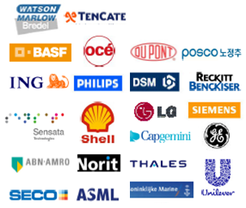
曾辅导超过56个许多知名企业于创新解决问题与新产品开发相关项目POSCO(浦项钢铁)、Unilever(联合利华公司)、ING (安泰投信)、Philips (飞利浦照明)、SHELL (壳牌)、SECO (山高)、ASML(艾司摩尔)、LG集团(乐喜金星集团)、DSM(帝斯曼)...等。
- 培训超过 4,000位萃智(TRIZ)专业人才，遍布全世界60多个国家
- 曾教授超过168堂商业管理系统性创新 & 科技工程相关课程
影片观赏- Valeri V. Souchkov TRIZ 基本介绍影片
【著作】
总共有75篇著作；其中67篇为萃智创新(TRIZ)相关著作
书籍：2本
课程教材：4本
国际会议与期刊：38篇
白皮书：24篇
• In 2010, co-authored the book "Systematische Innovation: TRIZ-Anwendung in der Produkt- und Prozessentwicklung" (ISBN 978-3446421325) published by Hanser Verlag, Germany.
• In 1999 edited, adapted and published the book "TRIZ: The Right Solution at The Right Time" (ISBN 90-80468010) by Yuri Salamatov, Ph.D which has been considered one of the bestselling books on TRIZ worldwide, and was translated to Japanese by Mitsubishi Research Institute.
• In 1998 authored the monograph "Knowledge Based Support for Innovative Engineering Design" which summarized the results of the research project on modeling sharable physical knowledge for innovation.

